
BIM User Guide: July 2021
ACO PowerDrain Sealin V100G

User Guide for Autodesk Revit files

ACO PowerDrain Sealin V100G Packages

All ACO PowerDrain Sealin V100G are incorporated in a single Revit template along with accessories.
This template includes the following families:
- Channel body without bottom slope (straight channel - 1m and 0.5m)
- Channel body without bottom slope LLD (straight channel with vertical outlet - 1m and 0.5m)
- Channel body with bottom slope (slope channel - 1m and 0.5m)
- Channel body with stepped sole (Stepped adapter - 0.5m)
- Sump unit (Inlet boxes -0.5m)
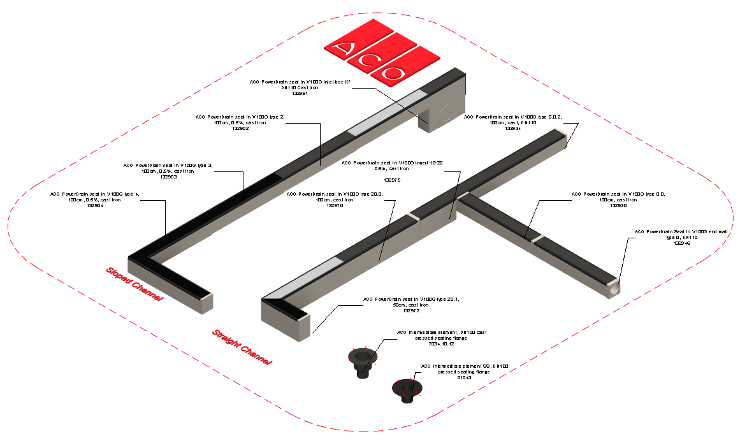

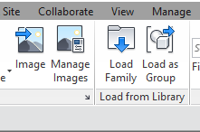
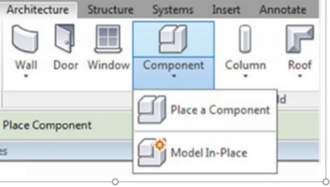
Loading ACO PowerDrain Performance into the project:

- Download the ACO PowerDrain Sealin V100G project file and save it to a suitable location

- Select any one of the family from ACO PowerDrain Sealin V100G
load to your project

- Navigate to the “Insert” icon on the Revit ribbon and click “Load Family”

- The file can now be placed into your project. Navigate to the “Architecture/Component” icons on the Revit ribbon and click “Place a Component”

Placing of families

- Click on the model – At properties tool bar, it will display family name and types.

- Every family consists of different types, the user has to select the appropriate family type from the “Properties” drop down menu.

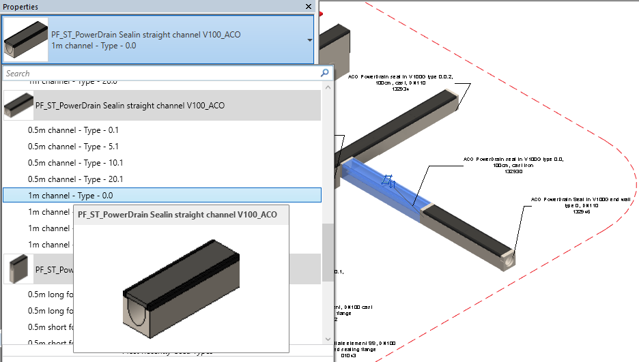

Selection of Gratings:

Click on the model – At properties tool bar, click on the grating drop menu and select the appropriate gratings for the channel.

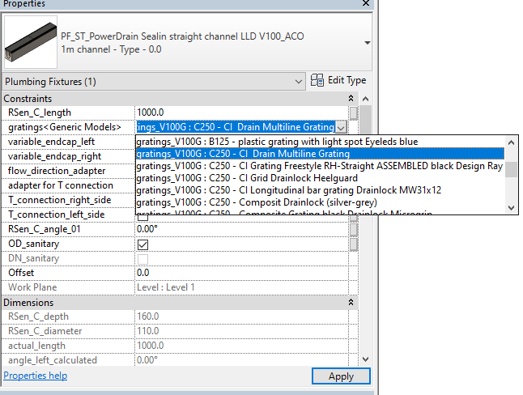

Selection of Accessories:

Click on the model – At properties tool bar, it will display accessories list such as endcaps, T connection adapter and flow direction adapter. User can select by click the list as shown below

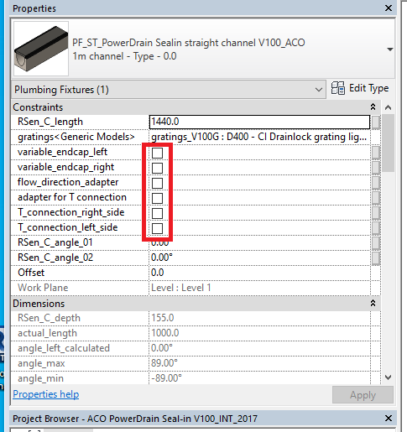

For Angular cut:

Click on the model – At properties tool bar, it will display two angles such as RSen_C_angle_01 (left side)
and RSen_C_angle_02 (right side). We can enter the corresponding angles to make the angular cut on the channels.
Note: While using Endcaps and adapters make sure that angular value should be as zero

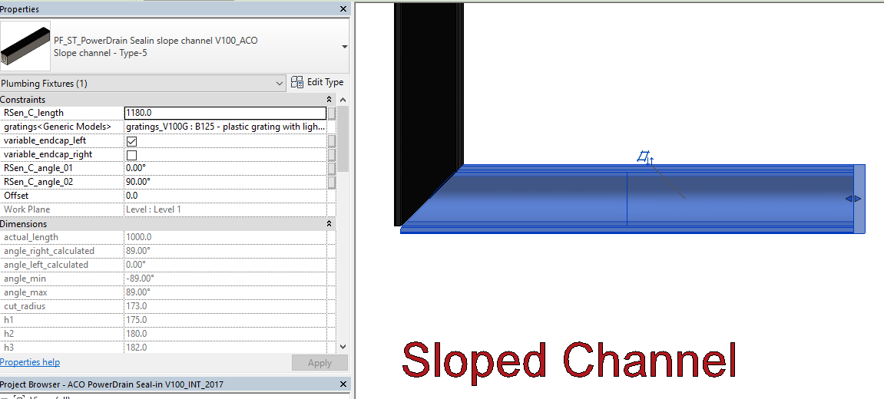

Material Library:
The ACO PowerDrain Sealin V100G files contain materials that are already pre-loaded into the components. When loading the ACO PowerDrain Sealin V100G files into your project the pre-loaded materials will automatically transfer through.

Schedules and quantities:

The information such as article number, GTIN data, weight, installation guidelines within the parameters is stored as “shared Parameters” so can easily be appeared when creating a schedule and quantities in the project environment.

